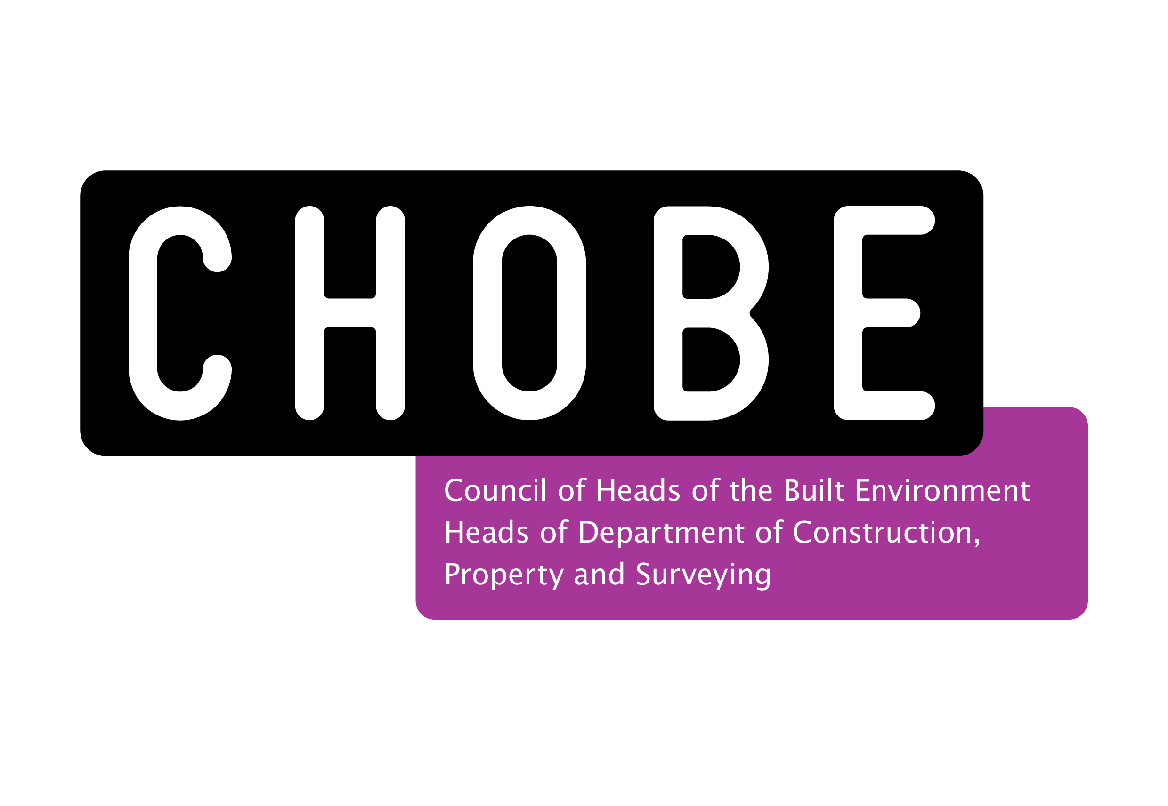@iBEE2020

Global Learning Innovations: Innovation in Built Environment Education Conference
Liverpool John Moores University, April 16/17
Proposal for presentation/workshop.
Please return this form by email as a word document to info@chobe.org.uk by 10th January 2020.

Name
Organisation
Email
Phone
Format | Workshop* (1 hour) or Presentation** (20 minutes): please delete as appropriate
Title (provisional)
Overview and rational | Please provide a brief overview of your proposal together with an explanation of its relevance to the theme of iBEE2019 (max 250 words).
Comments/feedback (for CHOBE use)
*Workshop: one hour allocated to presenter for the delivery of an interactive session with opportunity for discussion built in.
**Presentation: delegates will be scheduled a 1 hour sessionwith 2 other presenters (chosen by theme/relevance) to deliver presentation and engage in discussion.

