  Accredited Providers Conference 2026 | 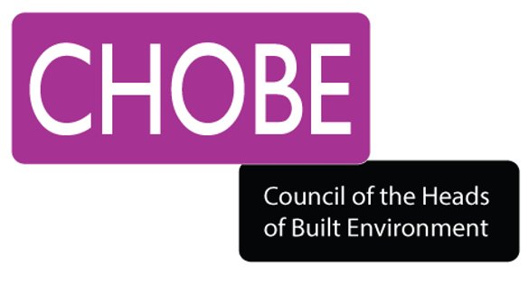

Technical & Professional Education:
Opportunities & Future Directions

Hosted by RICS, 10th and 11th September 2026, Westminster, London

CHOBE is delighted to confirm that Innovation in Built Environment Education (iBEE) 2026 will be hosted by RICS. The conference is organised in collaboration with the Associated Schools of Construction (ASC) and CIB W089 - Building Education and Research.

The UK’s top Learning and Teaching in Built Environment conference will run alongside the RICS Accredited Providers Conference – a platform for collaboration and engagement. Anticipated speakers include: RICS President, RICS Executive Director (Education and Qualification Standards), CHOBE and Property Research Trust.

Who should attend?  This in-person event seeks to engage with academics and practitioners across the construction and built environment disciplines looking to:  - Experience excellent and innovatory inter-disciplinary practice  - Participate in interactive presentations and workshop sessions  - Actively engage with and share new ideas  - Draw on the expertise of leaders and innovators | 

Conference Registration (Delegates) - Free to attend

  - Register via CHOBE link here

Call for Proposals – Deadline: 19 June 2026

To be considered for the iBEE 2026 stream, delegates will need to submit a short proposal to CHOBE on the enclosed form for:

- 20-minute presentation (including Q&A)
OR
- 1-hour workshop (interactive with discussion).

To submit your proposal:

- A copy of the submission form is included with this email as an attachment.

- Numbers are limited so we really would recommend encouraging your colleagues to send a proposal as soon as possible.

- Note: The closing date for submission is 19 June 2026.

  - Completed proposals should be sent to info@chobe.org.uk, as should any queries about the event.

This is a fantastic opportunity for people who want to share and showcase their innovative and emerging practice.

We look forward to welcoming you at iBEE2026 in September!

Any further queries please email info@chobe.org.uk

Best wishes

