
  Accredited Providers Conference 2026 |  | 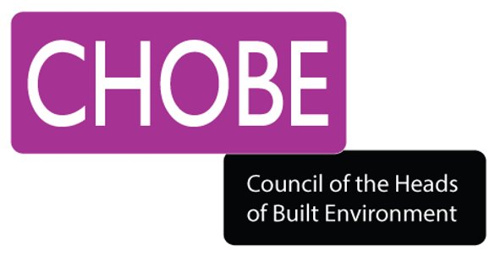

Technical & Professional Education:
Opportunities & Future Directions
Hosted by RICS,10th and 11th September 2026, Westminster, London

PROPOSAL FOR PRESENTATION/WORKSHOP

Please return this form by email as a Microsoft Word document to info@chobe.org.uk by 19 June 2026

NAME
ORGANISATION
EMAIL
PHONE
FORMAT | Workshop* (1 hour): ☐ | Presentation** (20 minutes): ☐
FORMAT | *Workshop: 1 hour allocated to presenter for the delivery of an interactive session with opportunity for discussion built in.
FORMAT | **Presentation: Scheduled 20 minute session with 2 other presenters (chosen by theme/relevance); to present and engage in discussion.
TITLE (PROVISIONAL)
OVERVIEW AND RATIONALE | Please provide a brief overview of your proposal together with an explanation of its relevance one or more of the conference themes listed (max 200 words):  - Digital Futures & AI: The impact of technology, AI and data on learning, teaching and assessment – opportunities and challenges.  - Future-Facing Learning: Exploring emerging pedagogies, curriculum innovation, hybrid/blended learning models, and learner-centred approaches.  - Skills, Talent & Apprenticeships: Building workforce capacity, capability and competence (e.g. apprenticeships, life-long learning and industry engagement).  - Professionalism, Ethics & Behaviours: Professional conduct, ethical practice, competence, equity, inclusion and behaviours in education & training.  - Policy & Systems: The changing skills landscape, including Post-16 reform, lifelong learning, funding and apprenticeships (e.g. LLE, Growth & Skills Levy)
OVERVIEW AND RATIONALE | Session Proposal (max 200 words): [Type text here]
COMMENTS/FEEDBACK (FOR REVIEWER USE ONLY)

